# **Marine Safety Information Bulletin**

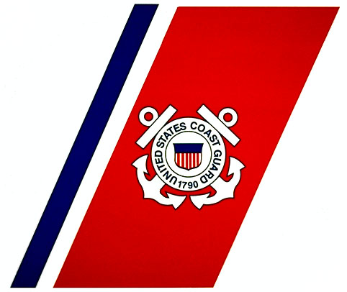

Commandant (CG-5PC) MSIB Number: XX-23

Attn: Inspections and Compliance Directorate Date: [XX July 2023]

U.S. Coast Guard

2703 Martin Luther King Jr Ave SE, Stop 7501

Washington, DC 20020 E-Mail: HQS-SMB-CG-672@uscg.mil

**Maritime Mobile Service Identities (MMSIs): What to do when Selling or Disposing of your Radio or Radio-equipped Vessel**

USCG [Marine Safety Alert 03-23](https://www.dco.uscg.mil/Portals/9/OCSNCOE/Casualty-Information/Safety-Alerts/CG-SA-03-23.pdf?ver=PwHijFHk2tmF6ba_kFpMZw%3D%3D) addressed means for ensuring proper configuration of digital selective calling (DSC)-equipped radios. Maritime Mobile Service Identities (MMSIs) are nine-digit numbers used by maritime radios equipped with digital selective calling (DSC), automatic identification systems (AIS), to uniquely identify a ship or a coast radio station. Registered MMSIs are used by Coast Guard search and rescue watchstanders to identity vessels or persons in distress and to save lives. Search and rescue authorities, including the Coast Guard, use the MMSI to learn background information about a vessel in distress (e.g., owner's name, intended route, and other radio equipment on board) and to determine whether the alert is false. An accurate MMSI database helps to protect lives and property at sea by reducing the time needed to locate vessels in distress. DSC distress calls or AIS identities with out-of-date MMSI registrations or invalid/missing positions make the determination of real distress situations versus an inadvertent DSC alert much more difficult. It is necessary to keep the MMSI registration current. It may save your life.

**Essential that you delete own ship MMSI, and cancel or transfer your MMSI and registration if you sell your radio or your boat**

If you decide to sell your radio, dispose of it or transfer it to another vessel, or sell your radio-equipped vessel, it is absolutely essential that you either delete own-ship MMSI and cancel your MMSI registration, or arrange to transfer your registration to the new owner prior to completing the sale.  If your vessel has more than one MMSI-equipped device, then you cannot transfer MMSI registration when you sell a single radio.  You must delete its MMSI.

If you forget to transfer and cancel your MMSI registration, or delete own-ship MMSI and cancel registration, then you could be held liable if and when the new owner improperly transmits a distress alert using the radio, or uses the AIS which you sold or disposed.

**Selling your Boat**

Vessel sale or online equipment purchase without properly changing or passing on the MMSI is a significant problem. The MMSI goes with the vessel, not with the user: here is what you need to do.

* **Option 1**: Contact the manufacturer of each AIS and DSC-equipped radio on the vessel, and have its own-ship MMSI deleted.  Confirm that own-ship MMSI has been deleted by switching on the radio.
* **Option 2**: Transfer your MMSI registration to the new vessel owner at the time the vessel is sold, following the Transferring MMSI Registration procedures below.

If you decide to remove and retain any AIS or DSC-equipped radio from the vessel being sold, the retained radio equipment must have its MMSI deleted. If the AIS or DSC-equipped radio is then to be used with another vessel, a new MMSI must be obtained and entered.

**Buying a Used VHF radio or AIS**

If you purchase a used VHF radio equipped with DSC, and an AIS, and are unable to get MMSI registration transferred from the original owner, you **must** contact the manufacturer in order to have the original own-ship MMSI deleted before using that radio.

**Deleting own-ship MMSI**

ITU regulations prevent you from deleting own-ship MMSI without advice from the radio manufacturer.  You will need to contact the manufacturer or its representative to determine how MMSIs are deleted on that particular model, regardless of whether it is DSC-equipped radio or an AIS unit.  For some models, deleting is easy, entering a code provided by the manufacturer.  For others, it is more difficult, requiring a visit by a dealer or the radio be removed and returned to the manufacturer. For that reason, anyone purchasing a DSC-equipped radio, or Class A or Class B AIS, is urged to find out how own-ship MMSIs are deleted on that radio prior to purchase.

**Cancelling and Transferring MMSI Registration**

[FCC](https://www.fcc.gov/wireless/bureau-divisions/mobility-division/maritime-mobile/ship-radio-stations/maritime-mobile), [BOAT US](https://www.boatus.com/products-and-services/membership/mmsi), [U.S. Power Squadron](https://www.usps.org/php/mmsi_new/), [Shine Micro](https://www.shinemicro.com/About-MMSI/) and [SEA TOW](https://seatow.com/marine-services/mmsi/)  allow you to cancel your registration on their website, and will allow you to transfer your registration, at least if the buyer and seller register with the same organization.  Transfer must occur by both the seller and buyer either simultaneously, or by showing proof that both parties concur with the transfer.   If you do not know which organization registered your MMSI, you can find out [here](https://www.navcen.uscg.gov/sites/default/files/pdf/MMSIAllotments/MMSIAllotments.pdf).

If you purchased a radio and are unable to contact the seller to transfer the MMSI registration, then you must contact the radio manufacturer and have the radio’s own-ship MMSI deleted.

If you sold the radio and are unable to contact the purchaser to transfer the MMSI registration, then you must update your registration to note the situation and, if possible, identify the purchaser; then cancel the registration.  Cancelled MMSI registrations remain in the database and can be useful during search and rescue.

For further information, see the updated USCG Navigation Center [MMSI Webpage](https://www.navcen.uscg.gov/maritime-mobile-service-identity).

Questions concerning this notice may be forwarded to Coast Guard Spectrum Management and Communications Policy Division (CG-672) at [HQS-SMB-CG-672@USCG.MIL](mailto:HQS-SMB-CG-672@USCG.MIL) or to the [Coast Guard Navigation Center’s “Contact Us” page](https://www.navcen.uscg.gov/contact/contact-us) by selecting ”Maritime Telecommunications” as subject.

-uscg-